

EasyAzure 2.0

EasyBackup Acronis Deployment Script

Contents

1 Introduction 3

2 Enabling EasyAzure 4

3 Creating Acronis Storage Gateway VM 6

4 Adding Storage Node to Acronis Management Server 10

1. Introduction

EasyBackup Acronis is a storage gateway for Acronis Backup totally on Cloud that enables a service provider to easily adjust any supported back-end storage to the Acronis proprietary data format. EasyBackup Acronis is distributed as a package for installation on a machine running Linux.

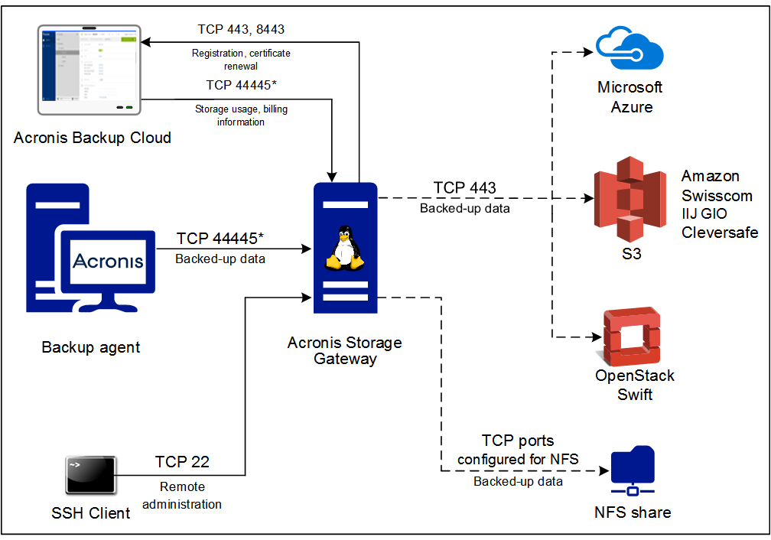

This document will guide you through the steps of setting up a storage gateway for Acronis on Azure.

If you want to backup to on-premises back-ends, you must have a VPN connection.

1. Enabling EasyAzure

**In order to identify EasyAzure solutions on your Azure Portal and, in this way, receive future package improvements and specific support for EasyAzure solutions, proceed as follows:**

On the Hub menu, click **[+ New]**, then type **template** and press **Enter**.

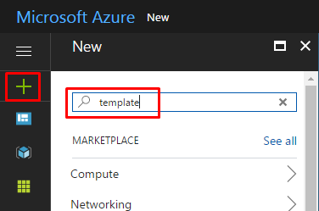

Select the option **[Template deployment]** and click **[Create].**

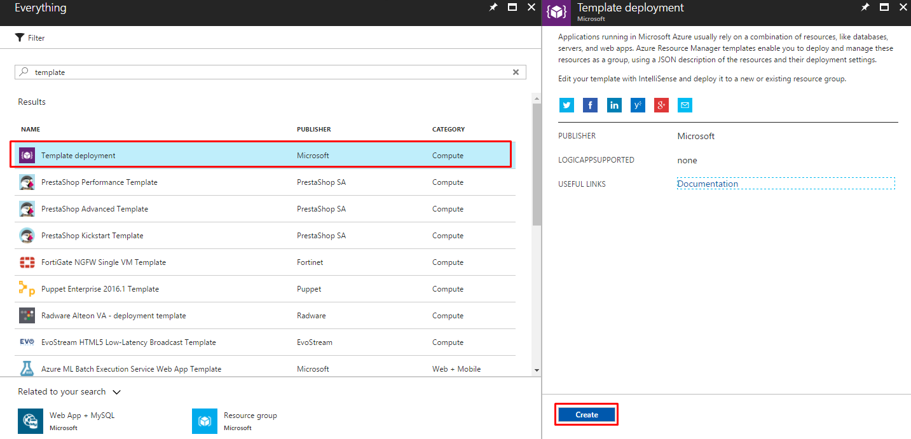

Click **[Build your own template in the editor]** and click **[Load file].** Select the file “easyazure.json”.

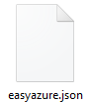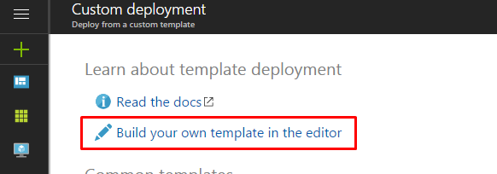

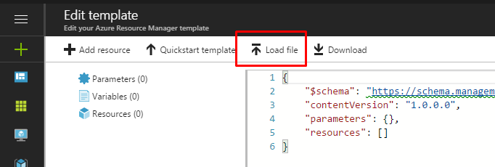

After loading the file and see the complete code, click **[Save].**

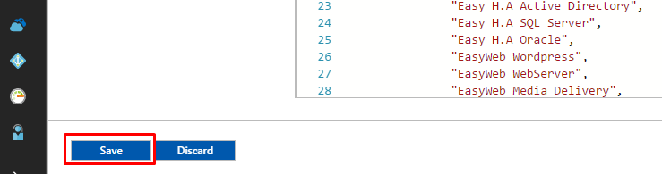

Make sure that the correct subscription is in the **[Subscription]** field and create a new resource group named **EasyAzure** in the **[Resource group]** field. Also check the option in the **[Location]** field, which should be the closest to you.

Select the correspondend **[EasyAzure Package]**, check the box with **[I agree to the terms and conditions stated above]**, then click **[Purchase]**. (PS. There are no fees in this step)

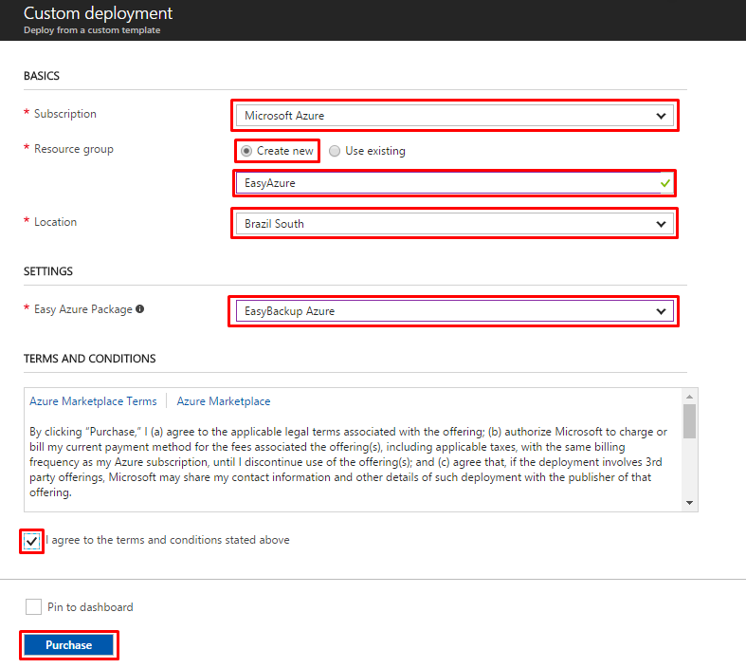

Wait for the deployment to complete.

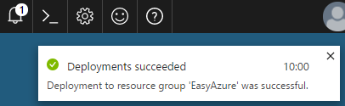

1. Creating Acronis Storage Gateway VM

If you have not already done so, enter the Azure Portal <http://portal.azure.com> using your Azure subscription.

On the Hub menu, click **[+ New]**, then type **acronis** and press **Enter**.

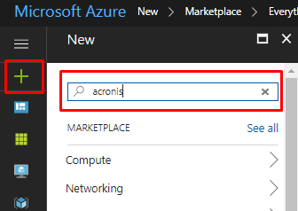

Select the option **[Acronis Storage Gateway]** and click **[Create].**

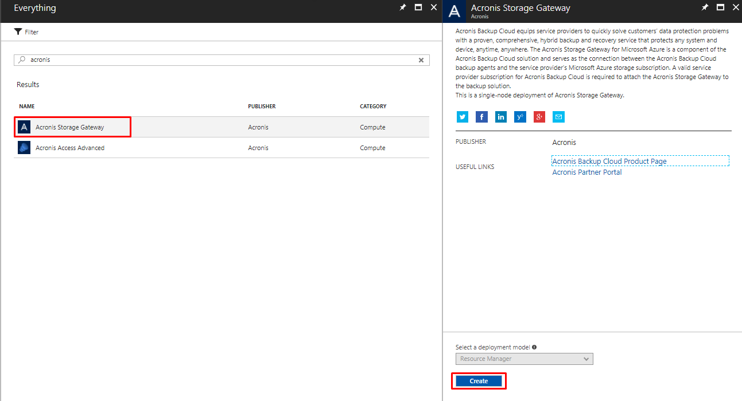

On the **[Basics]** blade, define an **[User name]** to access the server, type a **[Password]** and **[Confirm password]**, choose the right **[Subscription]** and create a new **[Resource group]**. Do not forget to choose the closest **[Location]** to you. Click **[OK]**.

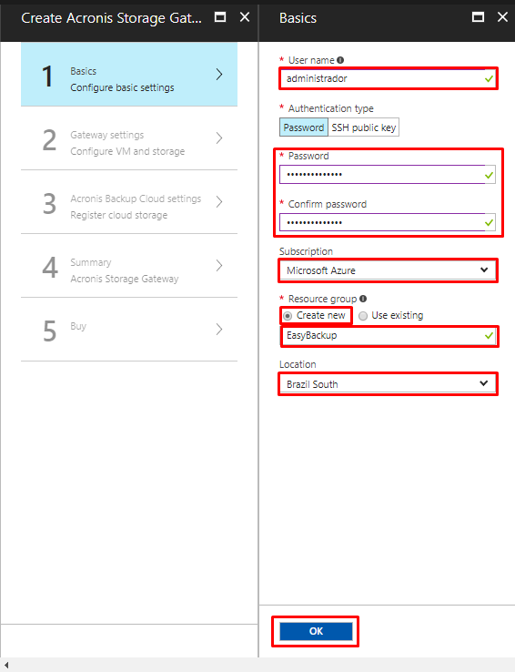

On **[Gateway Settings]** blade, define a **[Storage Account]** by clicking **[Create new]** and setting a **[Name],** then click **both [OK]**.

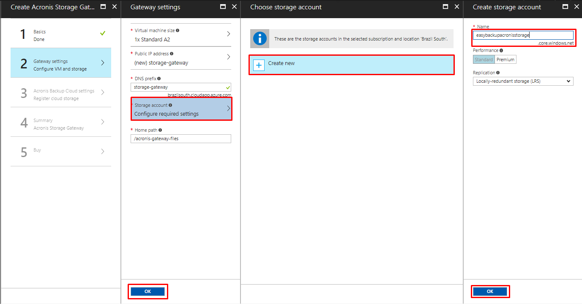

On the **[Acronis Backup Cloud Settings]** blade, enter your Acronis credentials and then click **[OK].**

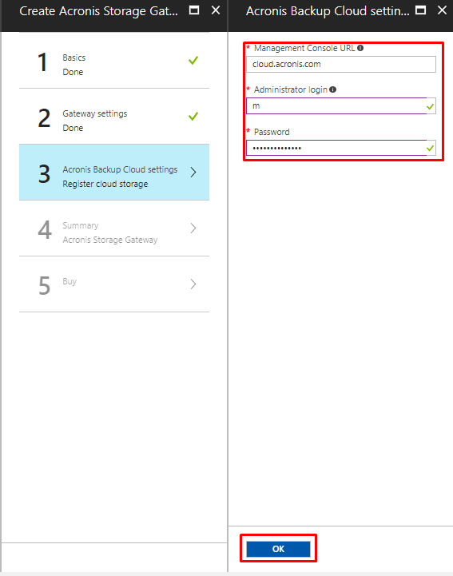

On the **[Summary]** check the information and click **[OK]**:

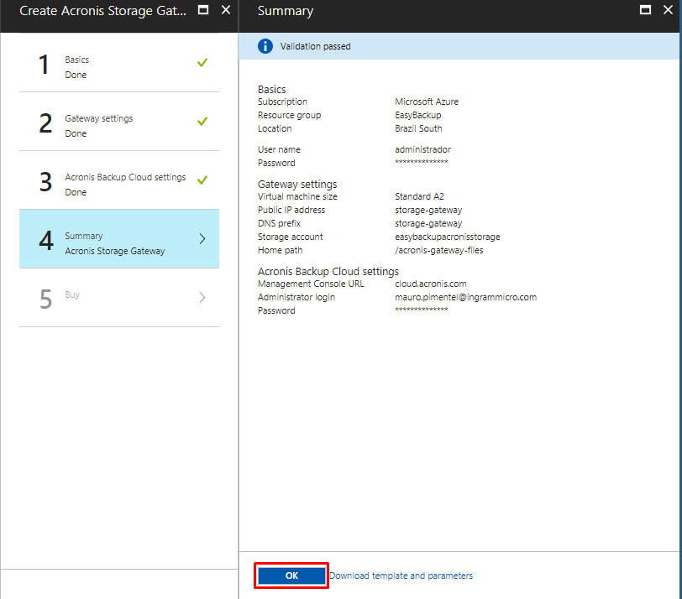

Click **[Create]:**

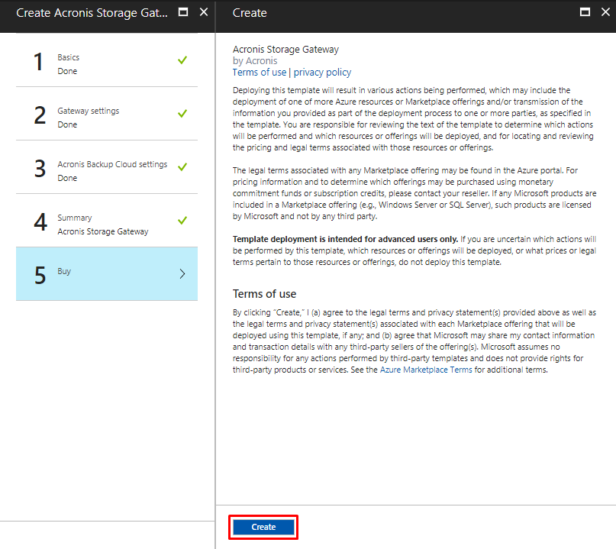

After its creation, click **[Tags]**, then type **[EasyAzure]** on both fields **[Key]** | **[Value]**, then click **[Save]** and wait for its conclusion.

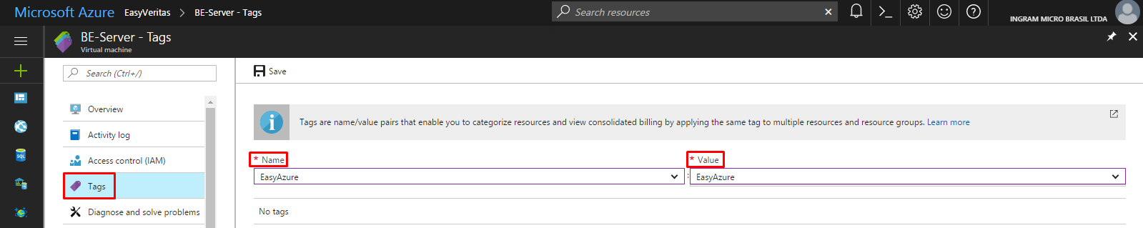

1. Adding Storage Node to Acronis Management Server

Connect to Acronis Management Server:

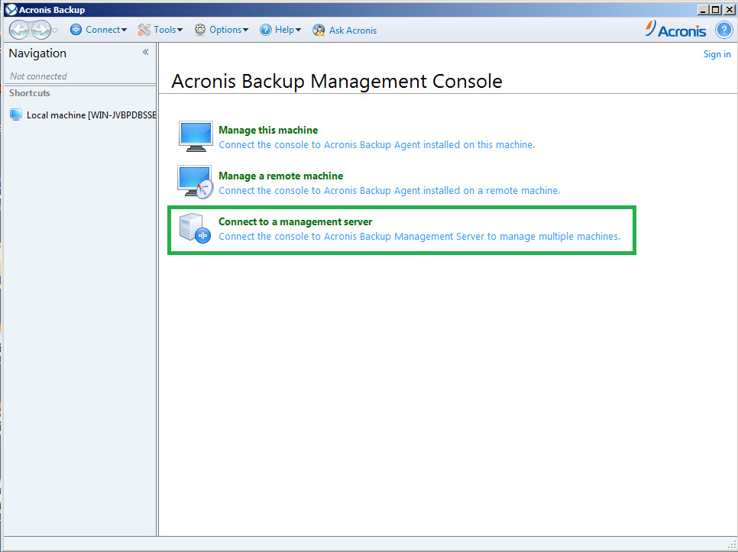

Select **[Storage Nodes]** in the Navigation menu and press **[Add storage node]**:

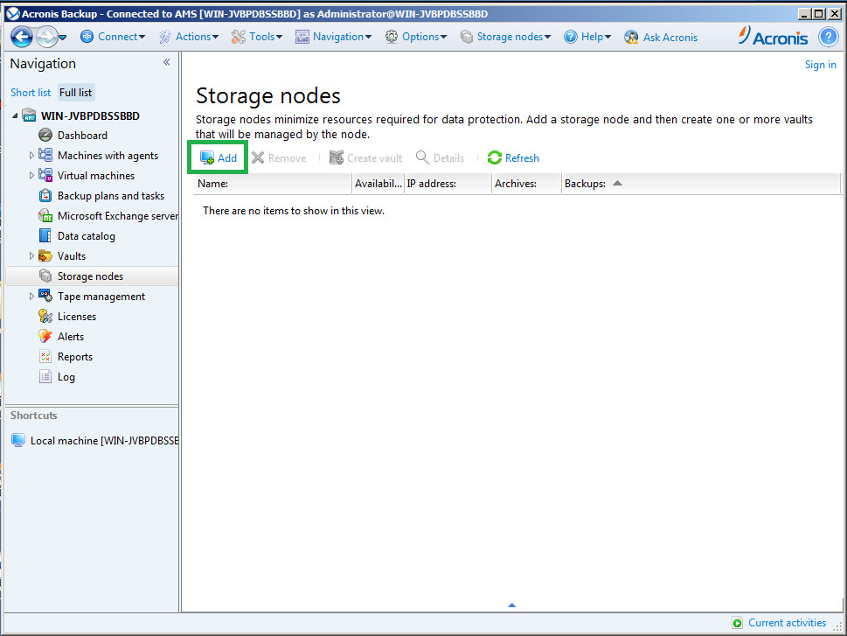

Specify the name or **[IP address]** of the machine where Storage Node is installed and specify **[credentials for connection]** and click **[OK].**

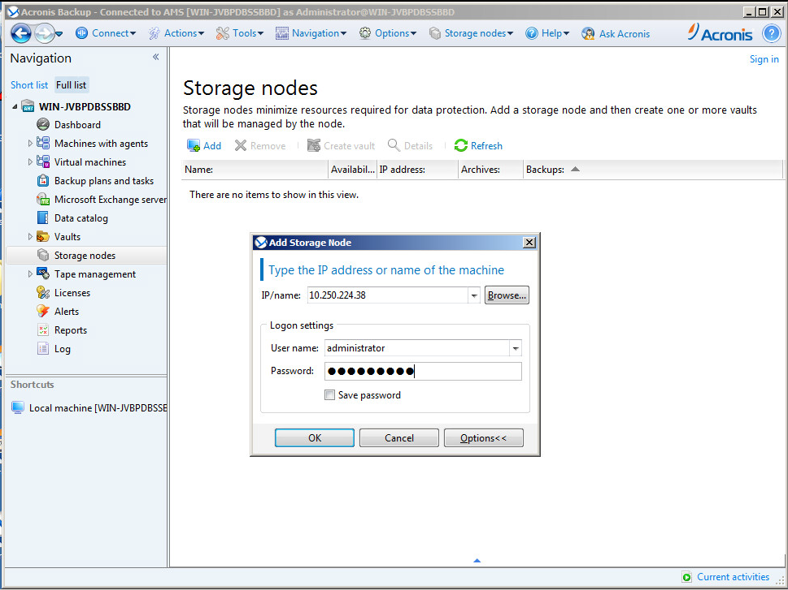

Wait for the configuration to complete.